



SUBMITTED TO:

SUBMITTED BY:

DANISH ZULFIQAR
REGISTRATION NO.:

FA21-BEE-042
SEMESTER-SECTION:

5-
B
COURSE:

EEE 462
Lab Report 06
BS Electrical Engineering
DR. DILSHAD SABIR
Artificial Intelligence

Lab Tasks:
Activity 1:
Code:
import random
import math

class ga:
def __init__(self,individualsize, populationsize):
self.population = dict()
self.individualsize = individualsize
self.populationsize = populationsize
self.totalfitness = 0
i = 0
while i < populationsize:
listofbits = [0]*individualsize
listoflocations = list(range(0, individualsize))
numberofones = random.randint(0, individualsize-1)
oneslocations = random.sample(listoflocations, numberofones)
for j in oneslocations:
listofbits[j] = 1
self.population[i] = [listofbits, numberofones]
self.totalfitness = self.totalfitness + numberofones
i = i+1

def updatepopulationfitness(self):
self.totalfitness = 0
for indvidual in self.population:
individualfitness = sum(self.population[indvidual][0])
self.population[indvidual][1] = individualfitness
self.totalfitness = self.totalfitness + individualfitness

def selectparents(self):
roulettewheel = []
wheelsize = self.populationsize*5
h_n = []
for individual in self.population:
h_n.append(self.population[individual][1])
j = 0
for individual in self.population:
individuallength = round(wheelsize*(h_n[j]/sum(h_n)))
j = j+1
if individuallength > 0:
i = 0
while i < individuallength:
roulettewheel.append(individual)
i = i+1
random.shuffle(roulettewheel)
parentindices = []
i = 0
while i < self.populationsize:
parentindices.append(roulettewheel[random.randint(0, len(roulettewheel)-1)])
i = i+1
newgeneration = dict()
i = 0
while i < self.populationsize:
newgeneration[i] = self.population[parentindices[i]].copy()
i = i+1
del self.population
self.population = newgeneration.copy()
self.updatepopulationfitness()

def generatechildren(self, crossoverprobability):
numberofpairs = round(crossoverprobability*self.populationsize/2)
individualindices = list(range(0, self.populationsize))
random.shuffle(individualindices)
i = 0
j = 0
while i < numberofpairs:
crossoverpoint = random.randint(0, self.individualsize-1)
child1 = self.population[j][0][0:crossoverpoint]\
+ self.population[j+1][0][crossoverpoint:]
child2 = self.population[j+1][0][0:crossoverpoint]\
+ self.population[j][0][crossoverpoint:]
self.population[j] = [child1, sum(child1)]
self.population[j+1] = [child2, sum(child2)]
i = i+1
j = j+2
self.updatepopulationfitness()

def mutatechildren(self, mutationprobability):
numberofbits = round(mutationprobability*\
self.populationsize*self.individualsize)
totalindices = list(range(0, self.populationsize*self.individualsize))
random.shuffle(totalindices)
swaplocations = random.sample(totalindices, numberofbits)

for loc in swaplocations:
individualindex = math.floor(loc/self.individualsize)
bitindex = math.floor(loc % self.individualsize)

if self.population[individualindex][0][bitindex] == 0:
self.population[individualindex][0][bitindex] = 1
else:
self.population[individualindex][0][bitindex] = 0
self.updatepopulationfitness()

individualsize, populationsize = 8, 10
i = 0
instance = ga(individualsize, populationsize)
while True:
instance.selectparents()
instance.generatechildren(0.8)
instance.mutatechildren(0.03)
print(instance.population)
print(instance.totalfitness)
print(i)
i = i+1
found = False
for individual in instance.population:
if instance.population[individual][1] == individualsize:
found = True
break
if found:
break
Output:
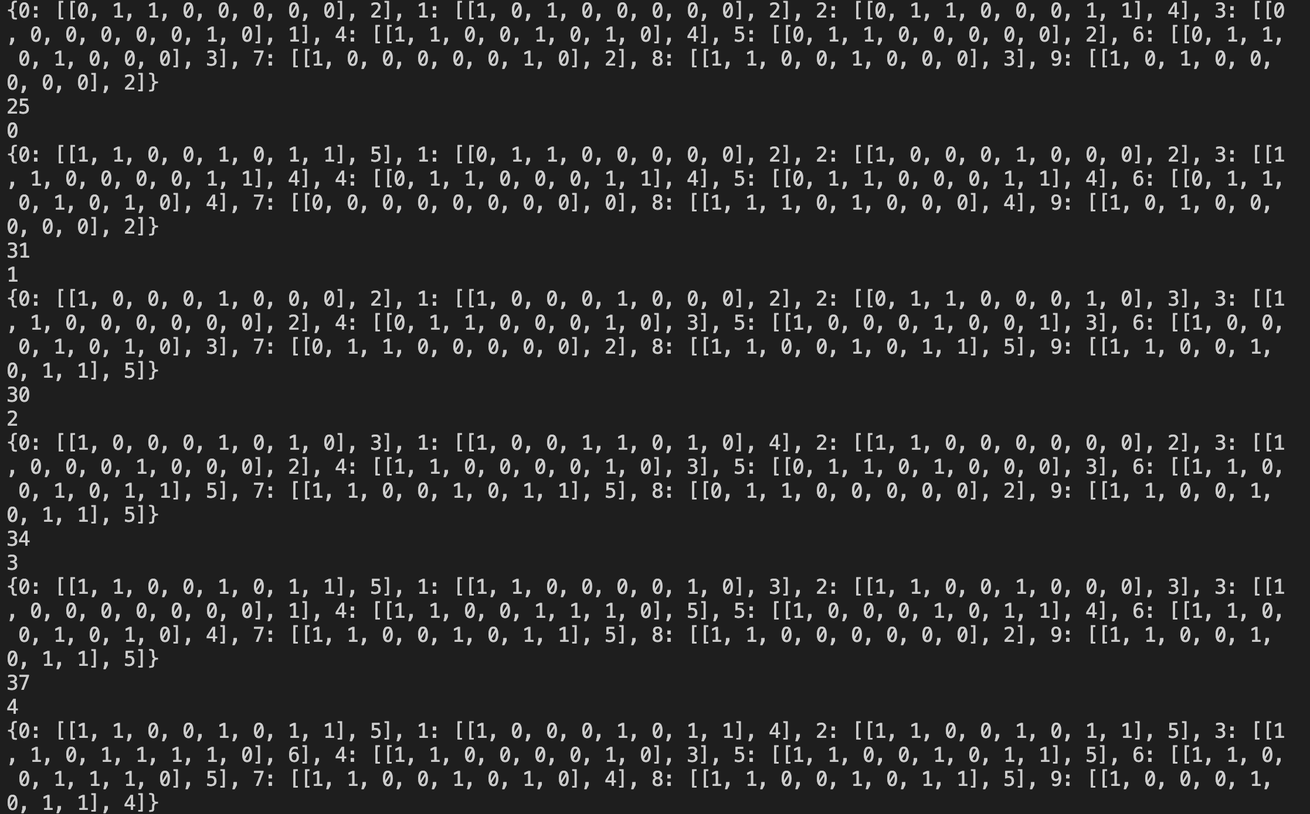

Activity 2:
Code:
import random
import math

class queensGA:
def updateIndividualFitness(self, individualArray):
i = 0
fitnessValue = 0
while i < self.individualSize:
j = 0
while j < self.individualSize:
if i != j:
if individualArray[j] == individualArray[i]:
fitnessValue = fitnessValue + 1
elif individualArray[j] == individualArray[i] - abs(j - i):
fitnessValue = fitnessValue + 1
elif individualArray[j] == individualArray[i] + abs(j - i):
fitnessValue = fitnessValue + 1
j = j + 1
i = i + 1
return fitnessValue

def selectParents(self):
rouletteWheel = []
wheelSize = self.populationSize * 5
h_n = []
for individual in self.population:
h_n.append(1 / (self.population[individual][1] + 1e-6)) # Add a small constant like 1e-6
j = 0
for individual in self.population:
individualFitness = round(wheelSize * (h_n[j] / sum(h_n)))
j = j + 1
if individualFitness > 0:
i = 0
while i < individualFitness:
rouletteWheel.append(individual)
i = i + 1
random.shuffle(rouletteWheel)
parentIndices = []
i = 0
while i < self.populationSize:
parentIndices.append(rouletteWheel[random.randint(0, len(rouletteWheel) - 1)])
i = i + 1
newGeneration = dict()
i = 0
while i < self.populationSize:
newGeneration[i] = self.population[parentIndices[i]].copy()
i = i + 1
del self.population
self.population = newGeneration.copy()
self.updatePopulationFitness()

def updatePopulationFitness(self):
self.totalFitness = 0
for individual in self.population:
individualFitness = self.updateIndividualFitness(self.population[individual][0])
self.population[individual][1] = individualFitness
self.totalFitness = self.totalFitness + individualFitness

def __init__(self, individualSize, populationSize):
self.population = dict()
self.individualSize = individualSize
self.populationSize = populationSize
self.totalFitness = 0
i = 0
while i < populationSize:
individualArray = [0] * individualSize
j = 0
while j < individualSize:
value = random.randint(0, individualSize - 1)
individualArray[j] = value
j = j + 1
self.population[i] = [individualArray.copy(), 0]
i = i + 1
self.updatePopulationFitness()

def generateChildren(self, crossoverProbability):
numberOfPairs = round(crossoverProbability * self.populationSize / 2)
individualIndices = list(range(0, self.populationSize))
random.shuffle(individualIndices)
i = 0
j = 0
while i < numberOfPairs:
crossoverPoint = random.randint(0, self.individualSize - 1)
child1 = self.population[j][0][0:crossoverPoint] + self.population[j + 1][0][crossoverPoint:]
child2 = self.population[j + 1][0][0:crossoverPoint] + self.population[j][0][crossoverPoint:]
self.population[j] = [child1, 0]
self.population[j + 1] = [child2, 0]
i = i + 1
j = j + 2
self.updatePopulationFitness()

def mutateChildren(self, mutationProbability):
numberOfBits = round(mutationProbability * self.populationSize * self.individualSize)
totalIndices = list(range(0, self.populationSize * self.individualSize))
random.shuffle(totalIndices)
swapLocations = random.sample(totalIndices, numberOfBits)
for loc in swapLocations:
individualIndex = math.floor(loc / self.individualSize)
bitIndex = math.floor(loc % self.individualSize)
value = random.randint(0, individualSize - 1)
while value == self.population[individualIndex][0][bitIndex]:
value = random.randint(0, individualSize - 1)
self.population[individualIndex][0][bitIndex] = value
self.updatePopulationFitness()

individualSize, populationSize = 8, 16
i = 0
instance = queensGA(individualSize, populationSize)
while True:
instance.selectParents()
instance.generateChildren(0.5)
instance.mutateChildren(0.03)
if i % 20 == 0:
print(instance.population)
print(instance.totalFitness)
print(i)
i = i + 1
found = False
for individual in instance.population:
if instance.population[individual][1] == 0:
found = True
break
if found:
print(instance.population)
print(instance.totalFitness)
print(i)
break

Output:
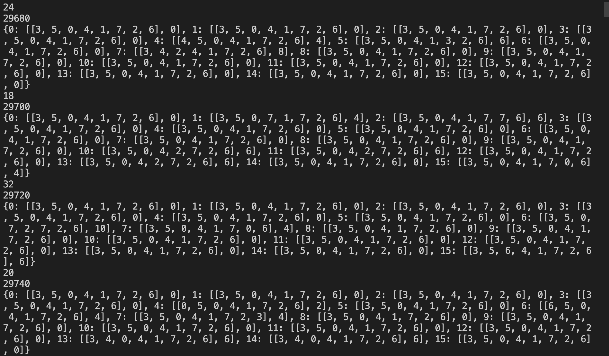

Home Activity:
Activity 1:
Code:
import random
import itertools
import math

def generate_points(num_points=15):
return [(random.uniform(0, 0.5), random.uniform(0, 0.5)) for _ in range(num_points)]

def distance(point1, point2):
return math.sqrt((point1[0]-point2[0])**2 + (point1[1]-point2[1])**2)

def heuristic(individual):
return sum(distance(individual[i], individual[i+1]) for i in range(len(individual)-1))

def crossover(parent1, parent2):
idx = random.randint(0, len(parent1)-2)
child1 = parent1[:idx] + parent2[idx:]
child2 = parent2[:idx] + parent1[idx:]
return child1, child2

def GA():
points = generate_points()
population = [random.sample(points, len(points)) for _ in range(45)]

for generation in range(100):
population.sort(key=heuristic)

population = population[:len(population)//2]

children = []
for i in range(0, len(population) - 1, 2):
child1, child2 = crossover(population[i], population[i+1])
children.append(child1)
children.append(child2)

for child in children:
if random.uniform(0, 1) < 0.1:
idx1, idx2 = random.sample(range(len(child)), 2)
child[idx1], child[idx2] = child[idx2], child[idx1]

population.extend(children)

population.sort(key=heuristic)
return population[0], heuristic(population[0])

solution, cost = GA()
print("Best Route:", solution)
print("Total Distance:", cost)

Output:
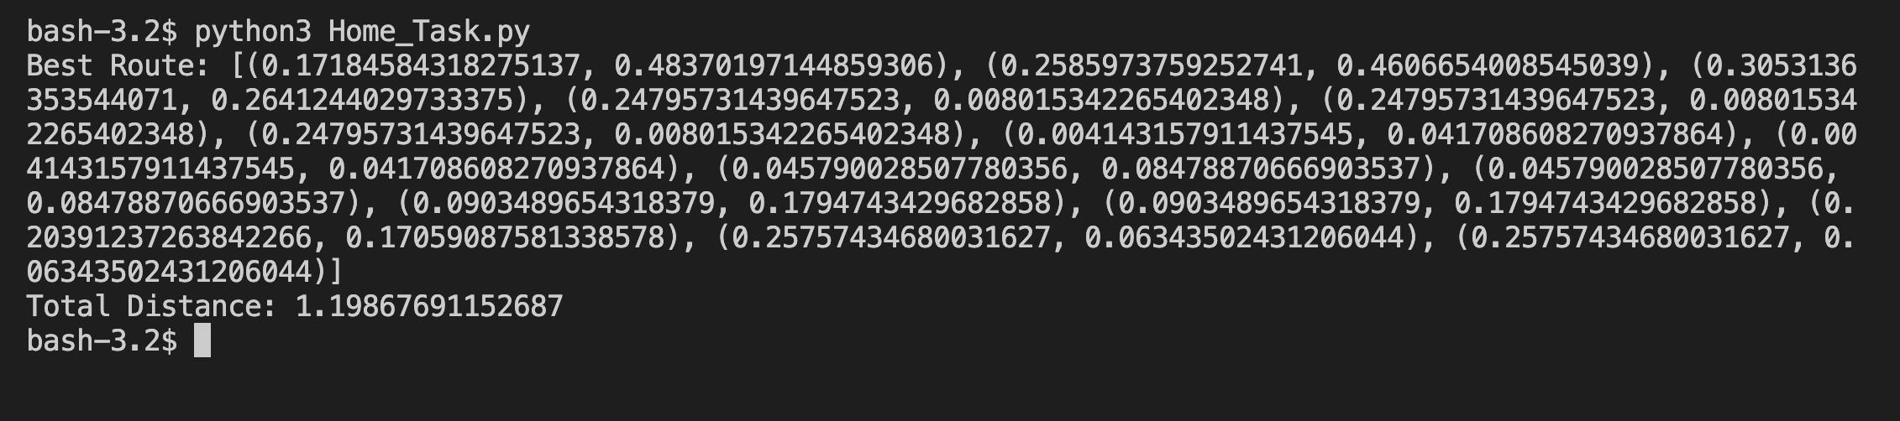

Critical Analysis and Conclusion:
While I performed the in-depth exploration of genetic algorithms in this lab, there were some nuances that stirred confusion. For instance, the process of encoding chromosomes into alphabets was introduced rapidly without ample foundational context. I found that selecting survivors based on the fitness function was a crucial component, but its application could have been elucidated more. The reference to Chapter 4 from Norvig's book provided valuable insights, yet integrating more hands-on examples during the session could bridge the gap between theory and application for many like us.

